**UAT-LES-Financial Statements taking too long to show up in LES**

As an example let’s take the policy VG00003684AA, which took about 2 hours to show up in LES after it was issued.

In this case, an MTA was done affecting the Premium as shown in the picture.

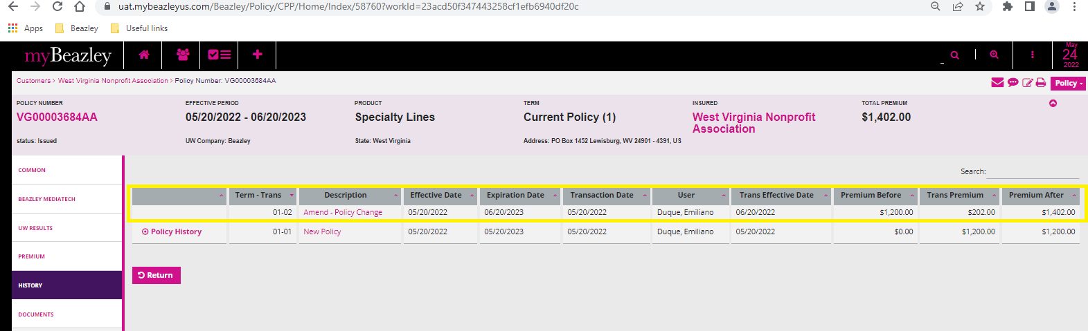

The additional financial transactions do not appear reflected in LES at all.

